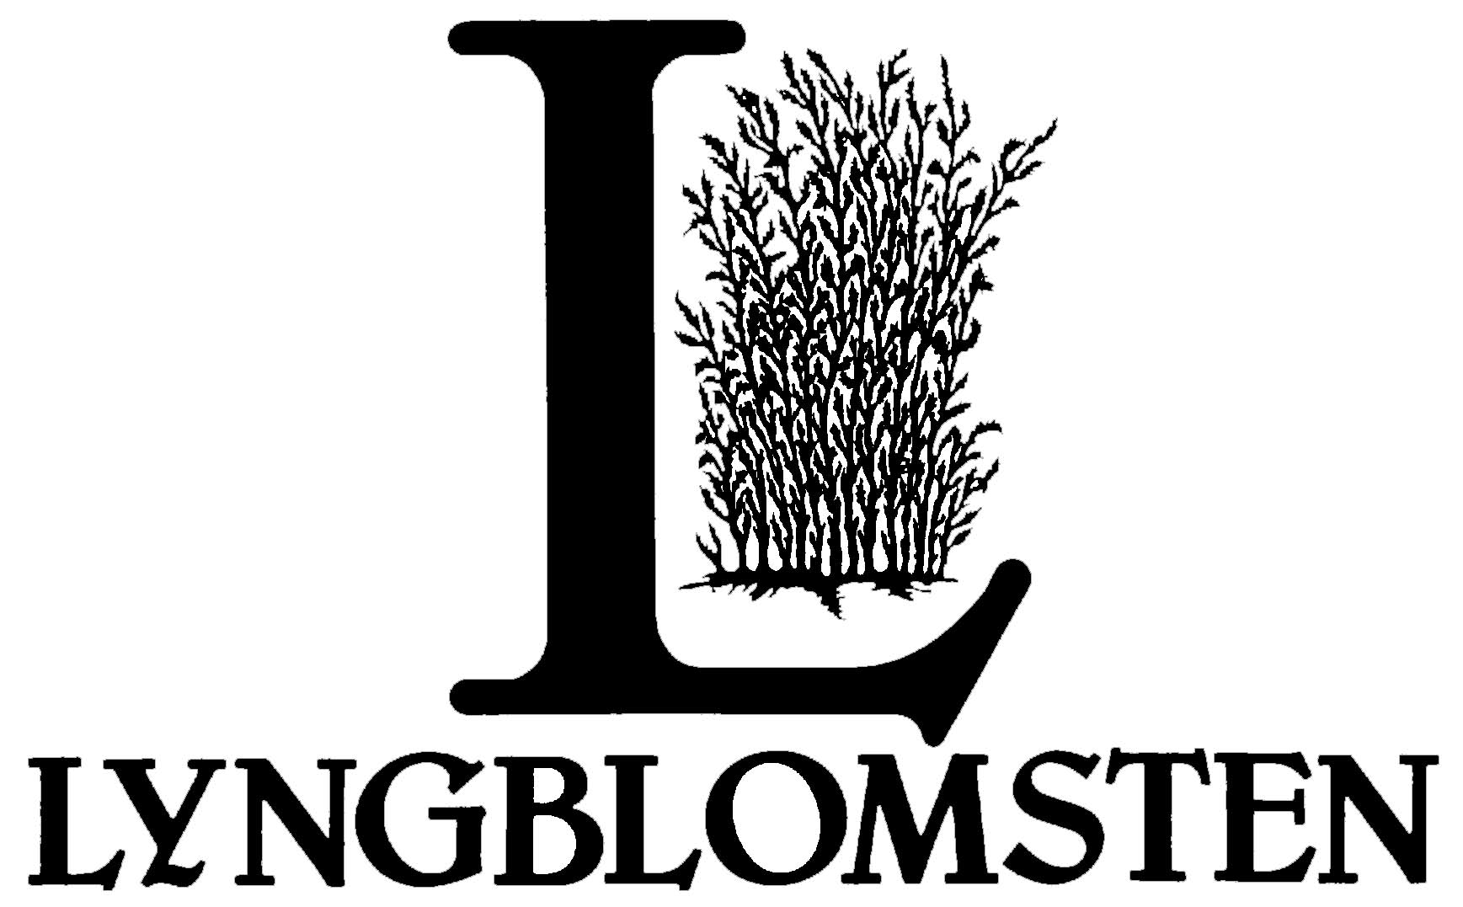
Lyngblomsten Parish Nurse Ministry Resource Group
2019 Monthly Network Meetings

Date / Time: 2nd Mondays at 1:00 – 2:30 PM

Questions or for more information, contact:
Becky Hulden, RN, Lyngblomsten Parish Nurse Ministry Resource Network Coordinator
(651) 632-5335 or bhulden@lyngblomsten.org

No meeting in January, enjoy the quiet!

February 11
Networking Meeting
Topic: Supporting the church staff
Location: Centennial United Methodist Church, 1524 County Rd C2 W, St Paul, MN 55113

March 11
Continuing Education Meeting
Program: Falls Prevention – Juniper.org
Presenter: Rachel Von Ruden, LSW. Community Outreach Specialist - MAAA
Location: Lyngblomsten Care Center Conference Room, 1415 Almond Avenue

April 15 – Date switched due to Westberg Symposium in Memphis.
Networking Meeting
Topic: Report from Westberg
Location: Lyngblomsten Care Center Classroom, 1415 Almond Avenue

May 13
Continuing Education Meeting
Program: Essential Oils and the Bible
Presenter: Paula Sevenich, Wellness Advocate, doTERRA International
Location: Centennial United Methodist Church, 1524 County Rd C2 W, St Paul, MN 55113

June 10
Networking Meeting
Topic: Walking the Labyrinth
Location: Como Park with catered lunch

No meeting in July, enjoy the sunshine!!

