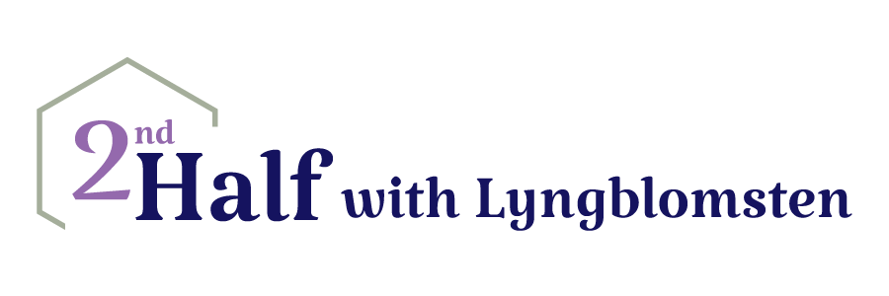

Date: June 29, 2020
To: 2nd Half with Lyngblomsten Participants, Gathering Participants, Family Caregivers, Volunteers and Program Partners
From: Julie Pfab, Director of Community Services
RE: 2nd Half with Lyngblomsten Program Plans for Remainder of 2020

Hello! We miss seeing you and hope that you are doing as well as possible and enjoying the warm weather.

COVID-19 has certainly affected our programming thus far in 2020, and it will continue to impact it for the foreseeable future. At this time, it is anticipated that 2nd Half with Lyngblomsten will not have any in-person activities or programs—including The Gathering—for the remainder of 2020 due to the COVID-19 restrictions. This difficult decision is based on the recommendations of the CDC and the Minnesota Department of Health. Coming together for in-person programming is not possible due to the size of our groups. Most programs typically exceed 10 people. In addition, the highest risk categories are those 65 and older or with underlying health concerns. The majority of our participants fall in one of these categories. As of today, neither the Lyngblomsten campus nor Redeemer Lutheran Church, or any of the churches that host The Gathering, have indicated a date of reopening for visitors.

Over the next couple months, 2nd Half with Lyngblomsten staff will explore, with the hope of starting, new virtual communities which might include:
- Armchair Traveler
- Books-Cheese-Wine
- Laugh & Chat
- Older Adult Ministry Forum
- Caregiver Educational Series

Planning has begun to have the following virtual services start within the next month:
- Caregiver support groups (started June 17, 2020)
- Group e-Respite
- Caregiver Coaching

Currently the Care Ministry Network and Parish Nurse Ministry Resource Group are meeting monthly via Zoom.

Over the next couple of months, we will be updating your contact information so we can keep you well informed. Please contact me with any questions or concerns; I can be reached at (651) 632-5331 or jpfab@lyngblomsten.org.

[Finally, please read this message from our President & CEO Jeff Heinecke, which he shared with the entire Lyngblomsten family today. During this challenging time, we've come together as a family to support and encourage one another. Click here to read his letter.]

Enjoy all the beauty of the summer and stay well.

